Assignment 7
Entity Framework Core
In this assignment you will expand your app with a new repository implementation, this time an actual database, but with EFC on top of it.

1 Status
You now have an actual client-server application, with a web site front end.
Your application should look something like this:
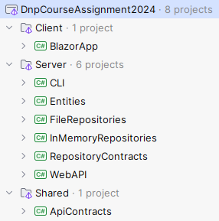
Or as a component diagram, we can show it like below. I have removed unused projects (CLI, and In-Memory repositories):
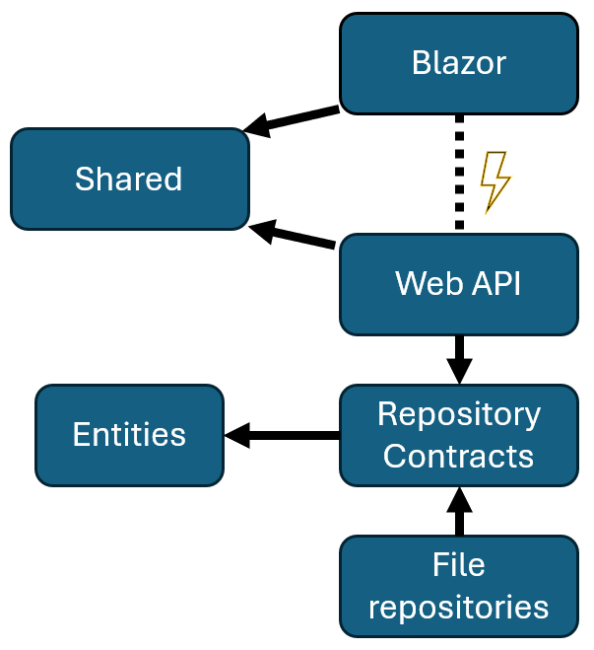

2 Setup
In your Server solution folder, create a new class library, I have called mine “EfcRepositories”.
Then add dependencies:
- EfcRepositories RepositoryContracts
- WebAPI EfcRepositories

3 Add EFC packages
I recommend using SQLite. If you have a strong urge to use Postgres or other relational database, you are free to do this. You will need other packages, than the ones mentioned below.
Add the following NuGet packages to your new class library:
- Microsoft.EntityFrameworkCore
- Microsoft.EntityFrameworkCore.Design
- Microsoft.EntityFrameworkCore.Sqlite

4 Add Context
Add a DbContext subclass to your new library, I have called mine AppContext. This is the “entry point” to the database.
Define necessary DbSets. This is what my class then looks like:
public class AppContext : DbContext
{
public DbSet<Post> Posts => Set<Post>();
public DbSet<User> Users => Set<User>();
public DbSet<Comment> Comments => Set<Comment>();
protected override void OnConfiguring(DbContextOptionsBuilder optionsBuilder)
{
optionsBuilder.UseSqlite("Data Source=app.db");
}
}

The class inherits from the DbContext, that’s necessary.
I define DbSets for each entity. Some tutorials will define them differently, as a normal property, that’s also fine.
The DbSet is essentially a representation of a table in the database.
In the OnConfiguring method, we specify to use Sqlite, and the database file is called “app.db”.

5 Update Entity Relationships
Now, this step will probably unfortunately break. Currently you are using foreign keys between your entities, one way or another. Or you should. Now, we will add associations, because that’s generally what EFC is using.
So, update the relationships of your domain entities so they match what EFC requires. You should watch the uploaded video series on this.
Include navigation properties in both directions.
You may delete the foreign key (which will break a lot, but this should be updated anyway) or specify it to be the foreign key. If you follow the naming conventions, it will happen automatically. Or you may need to specify it explicitly
I suggest including a private no-argument constructor in each entity, for example:

private User(){} // for EFC

This assumes all properties on your entities have a set; and get;. Either public or private.
Afterwards, you should fix potential errors in your Web API (and maybe CLI), which was caused by the change. Maybe there are none.

6 Generate migration
Once your DbContext is in place, and entities are updated, you need to create a migration.

6.1 Db tools
If this is your first time, you need to install some tooling to the CLI.
Open the terminal, and type in:
dotnet tool install -g dotnet-ef
You only need to do this once on your computer.

6.2 Create migration
To create a migration, in the terminal navigate to your EfcRepositories folder:
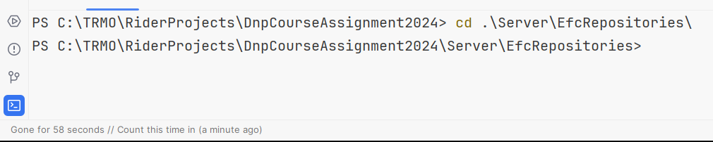

Then you type in the following command:
dotnet ef migrations add initial
The last “initial” is the name of this migration. You should name each migration after what is being changed.
It hopefully succeeds.
You should now see a Migrations directory in your project:
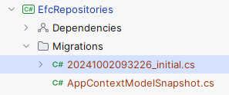
The selected file is the migration just created, it contains information about which tables and columns to create. Also about foreign keys. You can open it and scroll through.

Comment, Git:
My files are in red, because they are not tracked by git. If you work in a group, these migration files need to be tracked and shared to group members. Not the *Snapshot file though, this file keeps track of which migrations are applied to your local database. If your database is cloudhosted, the *Snapshot file needs to be tracked too.
If you cloud host your database, I recommend having one group member responsible for creating and applying migrations. It reduces the chance of messing up.

7 Create Database
Now, you have a migration. If you apply that to a non-existing database, the database will be created. In our case of using SQLite, it will create a *.db file.
In the terminal, type in the following command:
dotnet ef database update
Then, you should notice a new file:
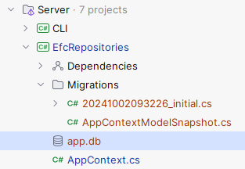
This is your database. In Rider, you can open it by double clicking, which will give you a view similar to DataGrip:
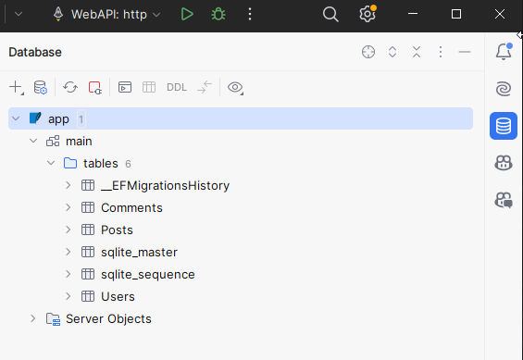
Please inspect your tables to verify they make sense. Do they have the right columns, primary, and foreign keys?
For VSCode, you can use the SQLite extension which serves a similar purpose.

8 Implement repositories
It’s time to implement the repositories. They are, again, very similar.
Each repository needs access to the DbContext, so inject that through the constructor:
public class EfcPostRepository : IPostRepository
{
private readonly AppContext ctx;
public EfcPostRepository(AppContext ctx)
{
this.ctx = ctx;
}
Then implement each method. Remember to call ctx.SaveChanges() when relevant.

8.1 Add
This is my code for the add post:
public async Task<Post> AddAsync(Post post)
{
await ctx.Posts.AddAsync(post);
await ctx.SaveChangesAsync();
return post;
}
Notice how when adding a Posts to the DbSet on the context, it will be automatically tracked by Entity Framework and an Id will be assigned to the Post.

8.2 Update
public async Task UpdateAsync(Post post)
{
if (!(await ctx.Posts.AnyAsync(p => p.Id == post.Id)))
{
throw new NotFoundException("Post with id {post.Id} not found");
}
ctx.Posts.Update(post);
await ctx.SaveChangesAsync();
}
First we check if the post exists.
Then we use the Update method.

8.3 Delete
public async Task DeleteAsync(int id)
{
Post? existing = await ctx.Posts.SingleOrDefaultAsync(p => p.Id == id);
if (existing == null)
{
throw new NotFoundException($"Post with id {id} not found");
}
ctx.Posts.Remove(existing);
await ctx.SaveChangesAsync();
}

In order to delete an entity, it must first be fetched, and then removed.

8.4 GetSingle
You should be able to implement this based on the above.

8.5 GetMany
public IQueryable<Post> GetMany()
{
return ctx.Posts.AsQueryable();
}
That’s it.

9 Update Web API
It’s time to update the Web API. You need to use the new repositories, and you might want to update the endpoints, because of how EFC can load associated data.

9.1 Swap repository implementations
In the WebAPI/Program.cs, swap the repository implementations.

9.2 Register DbContext
Each new repository is requesting an AppContext through the constructor. So, this has to be registered as a service too. There is a specific method for registering DbContexts:
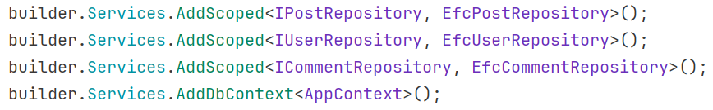

9.3 Test
You should be able to run your WebAPI now, and interact with it. You can use either the Blazor app, or just the swagger page opened by the Web API.
Just make a few requests, and verify they end up in the database, by inspecting the tables through the DataGrip-like database view. You can double click on a table (or refresh an open table), to inspect the data.

Comment
If you get an exception, with a message like:
This is because in your AppContext the path specified is relative to where the project is run. Running the project with “dotnet run” command will run the project from your source root, which is where the .db file is typically located. Running your app through other means may instead run it through the compiled binaries in the bin folder, which does not have the .db file. In that case, for convenience, you can change the relative path so that it correctly points to the .db file, or you can specify an absolute path (which will only work on your machine). The path is usually put into a configuration file.
You can right-click the app.db file and copy the absolute path:
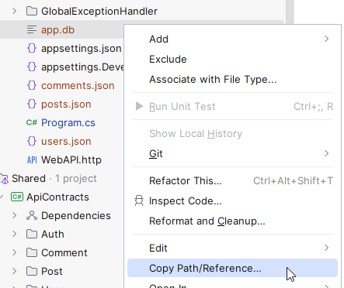
Then test again.

An alternative solution is to place the db file in a separate, local folder on the machine as done here.

Comment 2
If you are anywhere sending or receiving domain entities, you may now get an exception from JSON serialization, because of cycles. For example, my Post now references a User, which references a Post, which references a User, which…
This is a cycle. It cannot be serialized. And I don’t want it to.
So, in my AddPost endpoint, I previously returned the Post entity. It failed with the above exception. I’m now returning a PostDto instead. This class does not have the cycle.

9.4 Update endpoints
Most of your endpoints are just working with a single entity, in which case this should still work. But you should still look over if any synchronous methods can be made async now.

9.5 GetMany
These endpoints are probably synchronous currently, something like this:
[HttpGet]
public ActionResult<IEnumerable<User>> GetUsers([FromQuery] string? userNameContains = null)
{
IList<User> users = userRepo.GetMany()
.Where(
u => userNameContains == null ||
u.UserName.ToLower().Contains(userNameContains.ToLower())
).ToList();
return Ok(users);
}

Notice the ToList() call at the end. We can now update this to use ToListAsync(), which is a method we now have access to, because the Web API knows about EfcRepositories, which knows about EFC:
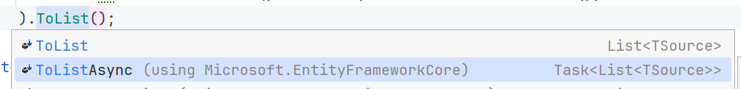
You can see here the ToListAsync() method exists in the Microsoft.EntityFrameworkCore namespace, which we didn’t have access to before we added this package to the EfcRepositories project.
To improve performance, update your ToList() calls to be async. This requires a change to the method signature too:
[HttpGet]
public async Task<ActionResult<IEnumerable<User>>> GetUsers([FromQuery] string? userNameContains = null)
{
IList<User> users = await userRepo.GetMany()
.Where(
u => userNameContains == null ||
u.UserName.ToLower().Contains(userNameContains.ToLower())
).ToListAsync();
return Ok(users);
}

Basically, where-ever you use the GetMany method, you may need to update a following synchronous call to async. For example, in my UsersController, when adding a User, I check if any user has the same username. Here I use AnyAsync().

9.6 Get entity with other entities
If you have an endpoint, which somehow interacts with multiple entities, you may look into updating it.
For example, I have an endpoint to retrieve a PostDto, and optionally the client can request to include comments, or author.
My current version, which you can see in the uploaded solution suggestion, will extract first the post, and then comments, and then author. As necessary. This results in multiple requests to the database, which works, but it can be done in one go instead, which increases performance. This is going to be a bit complicated.
Here’s the new endpoint:

[HttpGet("{id:int}")]
public async Task<IResult> GetPost(
[FromRoute] int id,
[FromQuery] bool includeAuthor,
[FromQuery] bool includeComments)
{
IQueryable<Post> queryForPost = postRepo
.GetMany()
.Where(p => p.Id == id)
.AsQueryable();
if (includeAuthor)
{
queryForPost = queryForPost.Include(p => p.User);
}
if (includeComments)
{
queryForPost = queryForPost.Include(p => p.Comments);
}
PostDto? dto = await queryForPost.Select(post => new PostDto()
{
Id = post.Id,
Title = post.Title,
Body = post.Body,
UserId = post.UserId,
Author = includeAuthor
? new UserDto
{
Id = post.User.Id,
UserName = post.User.UserName
}
: null,
Comments = includeComments
? post.Comments.Select(c => new CommentDto
{
Id = c.Id,
Body = c.Body,
AuthorUserId = c.UserId
}).ToList()
: new ()
})
.FirstOrDefaultAsync();
return dto == null ? Results.NotFound() : Results.Ok(dto);
}

Step 1: GetMany posts, filter by Id. Now I have a collection of a single post. This is an IQueryable, i.e. it is an SQL statement, but has not yet been executed.
Step 2: if includeAuthor is true, update the IQueryable queryForPost (i.e. the SQL statement) to include the comments of the post. This will automatically handle the joining of tables etc for us.
Step 3: The same with comments.
Step 4: Convert the Post to a PostDto with Select(). The first four properties should be straightforward: Id, Title, Body, UserId.
Step 5: Setting the Author property, I use the ternary expression here, i.e. “condition ? then : else”. If includeAuthor is true, create a new UserDto from the associated loaded Post.User. Otherwise just return null here.
Step 6: Similarly for the comments, if includeComments is true, convert the post.Comments to a list of CommentDto. Otherwise just an empty list, created with the “new ()”.
Step 7: Use FirstOrDefaultAsync() to just get the first PostDto (there should be only one, or zero). This call actually executes the SQL statement against the database. Up until now, we have just constructed the statement.
Step 8: Either return NotFound or Ok, based on whether the dto is null or not. It will be null if no post with a matching ID was found in the initial where clause.

Formalities
You may work on this assignment in groups.
You must have your assignment on GitHub.
You will hand in a link to your specific EfcRepositories folder on Github on itslearning, like previously.
Deadline can be found on itslearning.

